Guide for users

Creating a new user
Everyone can create new user’s account. In order to do that click Sign Up button on the homepage. Next fill in all fields and accept. Now you can log into Reservation System by filling in fields Login and Password and clicking Login on the right side of Navigation Bar.

Making a reservation
In order to make reservation open available reservations list by clicking appriopriate button marked at the following screenshot:
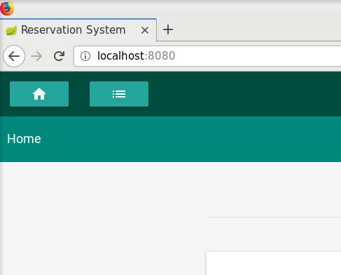
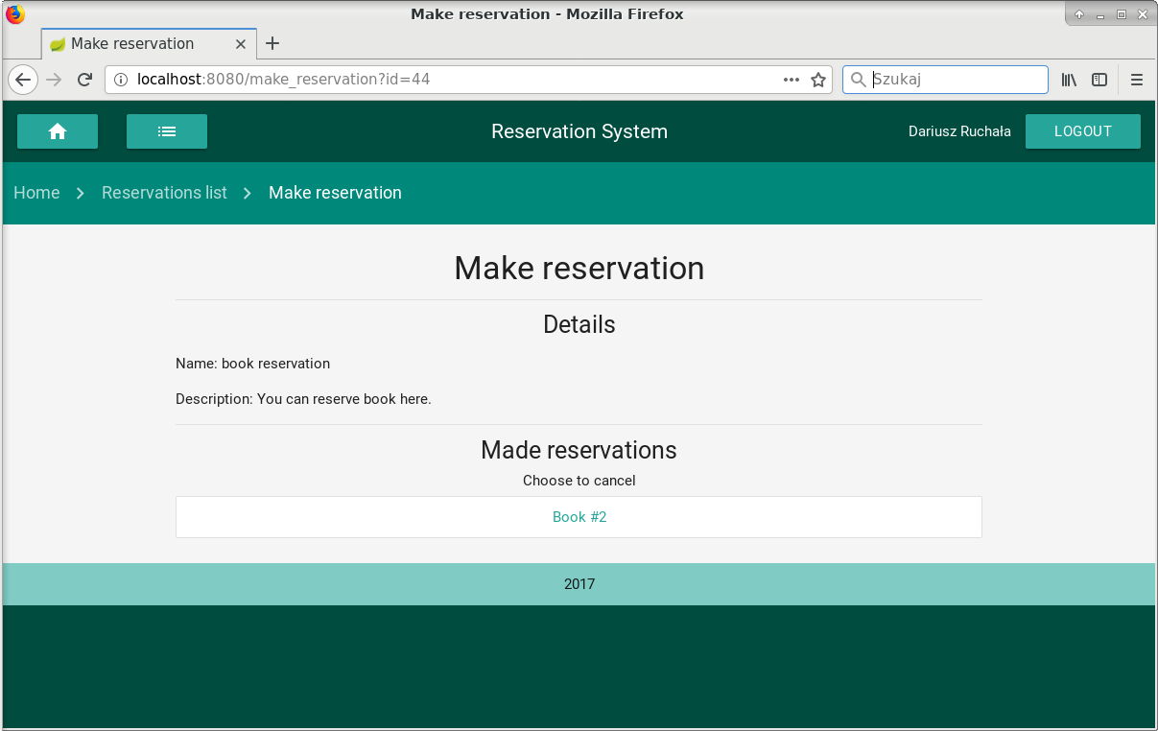
Then choose interesting reservation from the list. This list contains all reservations that has been created for your users group. You can be assigned to more than one users grups. Only administrator can creates and assigns users to groups. After that choose interesting resource from Available reservations. Then you can see, that resource was reserved by you, because now is in Made reservations section. Now author of reservation can see your made reservations.

Creating a new reservation
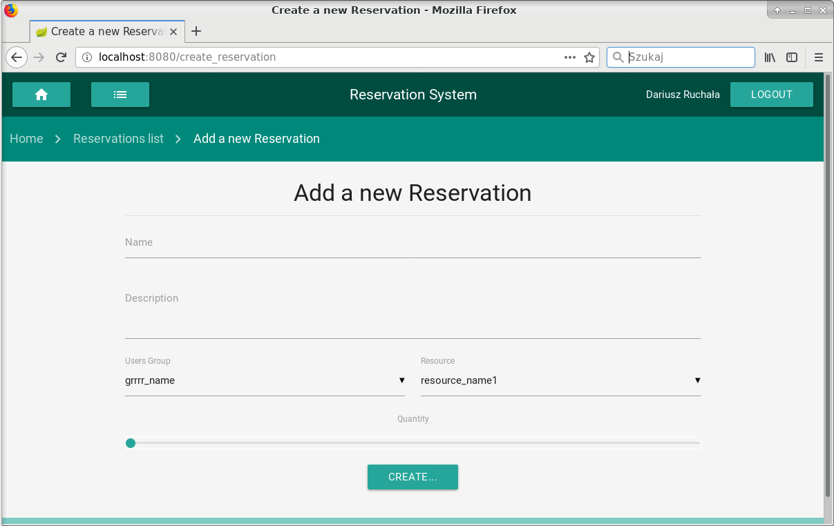
Every user can create his own reservation. In order to do that open Reservations list and click Add new Reservation. Then type the name of your reservation. Additionally you can add description as well. Next choose users group who will see your reservation and resource which can be reserved. At the bottom of the screen you have to choose how many resources will be available in the reservation. After all click Create... .

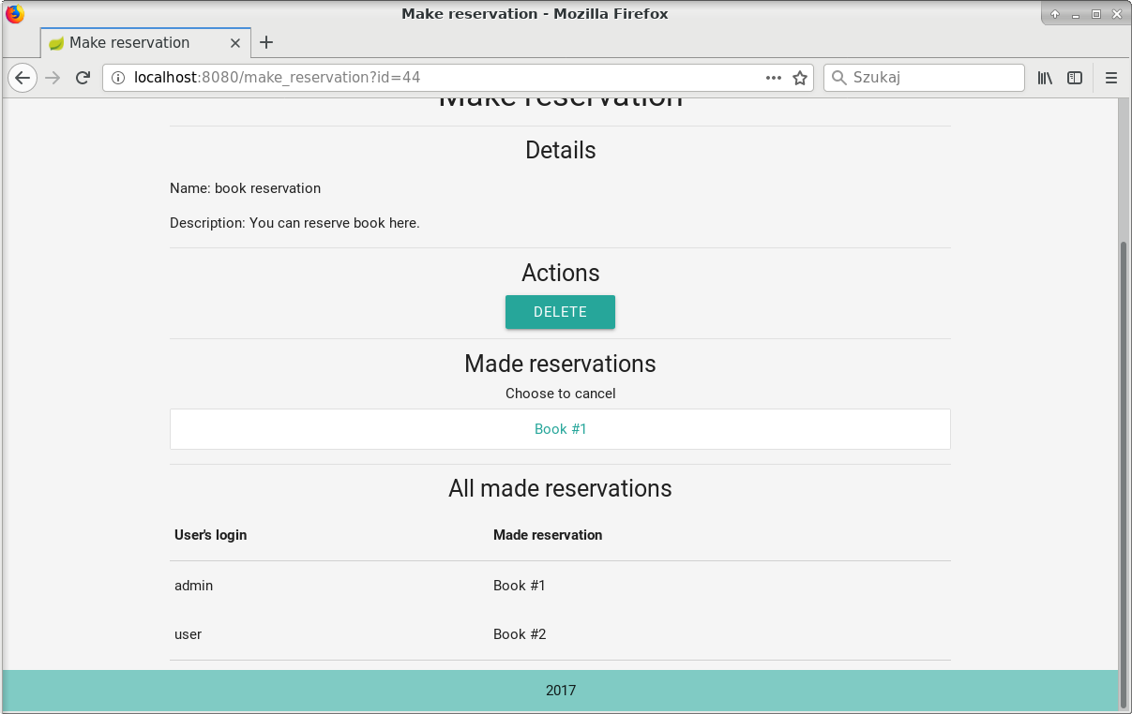
On the second screen you have to type labels of resources chosen in previous screen. If you finish that click Create. Now you reservation is available for all users from chosen users group. You can see who made reservations on reservations details screen in the seciont All made reservations. Also you can delete you reservatio by clicking Delete.

Guide for administrators

Deleting reservations
An administrator can delete an reservation by clicking Delete in the section Action on reservation details screen.

Settings screen
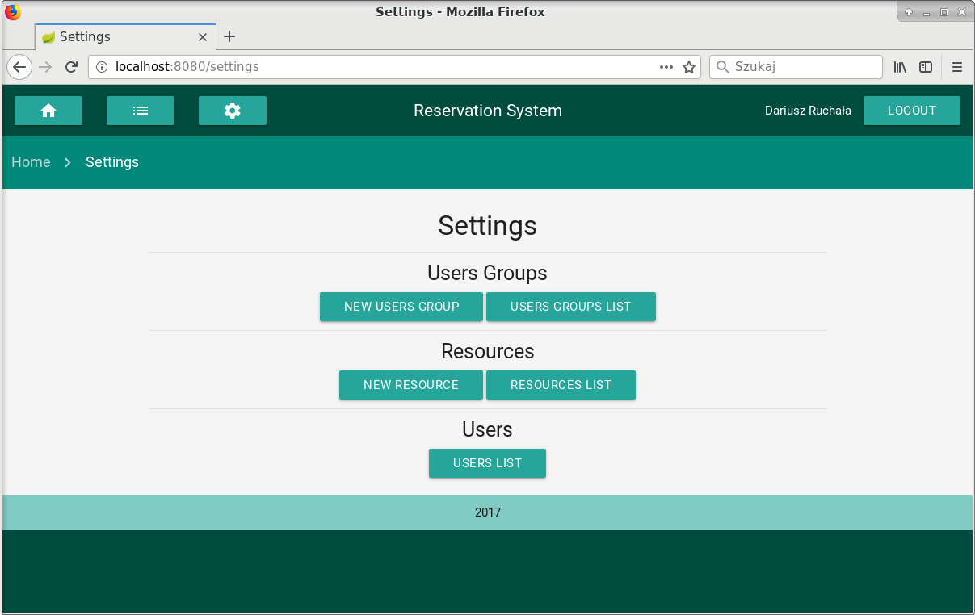
From Settings screen you can manage whole Resevation System. It is only available for users with administrators privileges. You can here create resources and users groups which will be available during creating new reservations. You can also delete users of the system or assign users to users group. One user can be assigned to many users groups.

